Loading node and edge data from Snowflake...
Loaded 150023 nodes and 156032 edges

====================================================================================================
PONZI SCHEME DETECTION ANALYSIS
====================================================================================================

Ponzi Scheme Indicators:
• Multi-level referral networks (pyramid structure)
• Early investors receiving payments from later investors
• High referral bonuses and recruitment incentives
• Unsustainable return patterns
• Rapid growth in participant base
• Funds flowing upward through referral chains
• Concentration of wealth at top of hierarchy

Pre-computing account relationships...
✅ Pre-computation complete!

Analyzing referral networks and pyramid structures...
Found 6000 referral relationships

✅ Referral analysis complete!

Detecting Ponzi scheme patterns...
✅ Pattern detection complete!

Analyzing referral chain structures...
✅ Found 126 referral chains

====================================================================================================
REFERRAL NETWORK STATISTICS
====================================================================================================

📊 Summary:
Total customers analyzed: 40005
Customers who made referrals: 5571
Total referral relationships: 6000
Average referrals per customer: 0.15
Maximum downstream network size: 7
Maximum referral chain depth: 6

====================================================================================================
TOP REFERRAL NETWORK ORGANIZERS
====================================================================================================

Rank Customer ID Name Direct Downstream Depth
--------------------------------------------------------------------------------
1 CUST036831 Derek Anderson 36831 2 7 5
2 CUST037069 Frank Martinez 37069 1 7 6
3 CUST010240 Lisa Anderson 10240 1 6 3
4 CUST010490 John Smith 10490 2 6 2
5 CUST012791 Maria Garcia 12791 1 6 3
6 CUST021762 Victoria Adams 21762 1 6 4
7 CUST023811 Amanda Wilson 23811 1 6 5
8 CUST033234 Olivia King 33234 2 6 4
9 CUST010701 David Williams 10701 1 5 2
10 CUST010981 James Martinez 10981 2 5 2
11 CUST012097 John Smith 12097 4 5 2
12 CUST013094 Nancy Martin 13094 2 5 3
13 CUST013267 John Smith 13267 3 5 3
14 CUST013749 Karen Garcia 13749 2 5 3
15 CUST015437 Linda Moore 15437 1 5 4

====================================================================================================
🚨 PONZI SCHEME SUSPECTS
====================================================================================================

Identified 142 customers with suspicious Ponzi-like patterns:

🔴 SUSPECT #1 (Risk Score: 100)
Customer: CUST013267 - John Smith 13267
Direct Referrals: 3
Total Downstream Network: 5
Referral Chain Depth: 3
Net Payment Position: $0.00
Red Flags:
• Deep referral chain (depth: 3) - pyramid structure
• Top of pyramid (no upstream referrer) - potential scheme founder
Referral Hierarchy:
Level 1: 3 recruits
Level 2: 1 recruits
Level 3: 1 recruits

🟠 SUSPECT #2 (Risk Score: 60)
Customer: CUST003258 - Daniel Thompson 3258
Direct Referrals: 3
Total Downstream Network: 3
Referral Chain Depth: 1
Net Payment Position: $0.00
Red Flags:
• Top of pyramid (no upstream referrer) - potential scheme founder
Referral Hierarchy:
Level 1: 3 recruits

🟠 SUSPECT #3 (Risk Score: 60)
Customer: CUST005805 - Robert Taylor 5805
Direct Referrals: 3
Total Downstream Network: 4
Referral Chain Depth: 2
Net Payment Position: $0.00
Red Flags:
• Top of pyramid (no upstream referrer) - potential scheme founder
Referral Hierarchy:
Level 1: 3 recruits
Level 2: 1 recruits

🟠 SUSPECT #4 (Risk Score: 60)
Customer: CUST006786 - William Brown 6786
Direct Referrals: 3
Total Downstream Network: 4
Referral Chain Depth: 2
Net Payment Position: $0.00
Red Flags:
• Top of pyramid (no upstream referrer) - potential scheme founder
Referral Hierarchy:
Level 1: 3 recruits
Level 2: 1 recruits

🟠 SUSPECT #5 (Risk Score: 60)
Customer: CUST006798 - William Brown 6798
Direct Referrals: 3
Total Downstream Network: 3
Referral Chain Depth: 1
Net Payment Position: $0.00
Red Flags:
• Top of pyramid (no upstream referrer) - potential scheme founder
Referral Hierarchy:
Level 1: 3 recruits

🟠 SUSPECT #6 (Risk Score: 60)
Customer: CUST006968 - Sarah Johnson 6968
Direct Referrals: 3
Total Downstream Network: 3
Referral Chain Depth: 1
Net Payment Position: $0.00
Red Flags:
• Top of pyramid (no upstream referrer) - potential scheme founder
Referral Hierarchy:
Level 1: 3 recruits

🟠 SUSPECT #7 (Risk Score: 60)
Customer: CUST007461 - Karen Garcia 7461
Direct Referrals: 3
Total Downstream Network: 3
Referral Chain Depth: 1
Net Payment Position: $0.00
Red Flags:
• Top of pyramid (no upstream referrer) - potential scheme founder
Referral Hierarchy:
Level 1: 3 recruits

🟠 SUSPECT #8 (Risk Score: 60)
Customer: CUST008547 - Richard Wilson 8547
Direct Referrals: 3
Total Downstream Network: 4
Referral Chain Depth: 2
Net Payment Position: $0.00
Red Flags:
• Top of pyramid (no upstream referrer) - potential scheme founder
Referral Hierarchy:
Level 1: 3 recruits
Level 2: 1 recruits

🟠 SUSPECT #9 (Risk Score: 60)
Customer: CUST009882 - Jessica Davis 9882
Direct Referrals: 3
Total Downstream Network: 3
Referral Chain Depth: 1
Net Payment Position: $0.00
Red Flags:
• Top of pyramid (no upstream referrer) - potential scheme founder
Referral Hierarchy:
Level 1: 3 recruits

🟠 SUSPECT #10 (Risk Score: 60)
Customer: CUST012666 - William Brown 12666
Direct Referrals: 3
Total Downstream Network: 3
Referral Chain Depth: 1
Net Payment Position: $0.00
Red Flags:
• Top of pyramid (no upstream referrer) - potential scheme founder
Referral Hierarchy:
Level 1: 3 recruits

🟠 SUSPECT #11 (Risk Score: 60)
Customer: CUST015656 - Jennifer Lee 15656
Direct Referrals: 3
Total Downstream Network: 3
Referral Chain Depth: 1
Net Payment Position: $0.00
Red Flags:
• Top of pyramid (no upstream referrer) - potential scheme founder
Referral Hierarchy:
Level 1: 3 recruits

🟠 SUSPECT #12 (Risk Score: 60)
Customer: CUST018799 - Nancy Martin 18799
Direct Referrals: 3
Total Downstream Network: 4
Referral Chain Depth: 2
Net Payment Position: $0.00
Red Flags:
• Top of pyramid (no upstream referrer) - potential scheme founder
Referral Hierarchy:
Level 1: 3 recruits
Level 2: 1 recruits

🟠 SUSPECT #13 (Risk Score: 60)
Customer: CUST028065 - Patrick Wright 28065
Direct Referrals: 3
Total Downstream Network: 3
Referral Chain Depth: 1
Net Payment Position: $0.00
Red Flags:
• Top of pyramid (no upstream referrer) - potential scheme founder
Referral Hierarchy:
Level 1: 3 recruits

🟠 SUSPECT #14 (Risk Score: 60)
Customer: CUST028337 - Elizabeth Thomas 28337
Direct Referrals: 3
Total Downstream Network: 3
Referral Chain Depth: 1
Net Payment Position: $0.00
Red Flags:
• Top of pyramid (no upstream referrer) - potential scheme founder
Referral Hierarchy:
Level 1: 3 recruits

🟠 SUSPECT #15 (Risk Score: 60)
Customer: CUST028830 - Christina Lopez 28830
Direct Referrals: 3
Total Downstream Network: 4
Referral Chain Depth: 2
Net Payment Position: $0.00
Red Flags:
• Top of pyramid (no upstream referrer) - potential scheme founder
Referral Hierarchy:
Level 1: 3 recruits
Level 2: 1 recruits

🟠 SUSPECT #16 (Risk Score: 60)
Customer: CUST031153 - Samuel Hill 31153
Direct Referrals: 3
Total Downstream Network: 3
Referral Chain Depth: 1
Net Payment Position: $0.00
Red Flags:
• Top of pyramid (no upstream referrer) - potential scheme founder
Referral Hierarchy:
Level 1: 3 recruits

🟠 SUSPECT #17 (Risk Score: 60)
Customer: CUST032033 - Isabella Rodriguez 32033
Direct Referrals: 3
Total Downstream Network: 3
Referral Chain Depth: 1
Net Payment Position: $0.00
Red Flags:
• Top of pyramid (no upstream referrer) - potential scheme founder
Referral Hierarchy:
Level 1: 3 recruits

🟠 SUSPECT #18 (Risk Score: 60)
Customer: CUST035388 - Elizabeth Thomas 35388
Direct Referrals: 3
Total Downstream Network: 3
Referral Chain Depth: 1
Net Payment Position: $0.00
Red Flags:
• Top of pyramid (no upstream referrer) - potential scheme founder
Referral Hierarchy:
Level 1: 3 recruits

🟠 SUSPECT #19 (Risk Score: 60)
Customer: CUST036875 - Katherine Walker 36875
Direct Referrals: 3
Total Downstream Network: 3
Referral Chain Depth: 1
Net Payment Position: $0.00
Red Flags:
• Top of pyramid (no upstream referrer) - potential scheme founder
Referral Hierarchy:
Level 1: 3 recruits

🟠 SUSPECT #20 (Risk Score: 60)
Customer: CUST038505 - Jacob Lewis 38505
Direct Referrals: 3
Total Downstream Network: 5
Referral Chain Depth: 2
Net Payment Position: $0.00
Red Flags:
• Top of pyramid (no upstream referrer) - potential scheme founder
Referral Hierarchy:
Level 1: 3 recruits
Level 2: 2 recruits

... and 122 more suspects

====================================================================================================
LONGEST REFERRAL CHAINS (Potential Ponzi Hierarchies)
====================================================================================================

Analyzing top 10 longest referral chains:

Chain #1 - Length: 4 levels
Root (Scheme Originator): CUST000517
Path: CUST000517 → CUST009507 → CUST010002 → CUST016437

Chain #2 - Length: 3 levels
Root (Scheme Originator): CUST000040
Path: CUST000040 → CUST000985 → CUST001367

Chain #3 - Length: 3 levels
Root (Scheme Originator): CUST000040
Path: CUST000040 → CUST000985 → CUST005253

Chain #4 - Length: 3 levels
Root (Scheme Originator): CUST000060
Path: CUST000060 → CUST004991 → CUST013107

Chain #5 - Length: 3 levels
Root (Scheme Originator): CUST000139
Path: CUST000139 → CUST006197 → CUST010431

Chain #6 - Length: 3 levels
Root (Scheme Originator): CUST000152
Path: CUST000152 → CUST002924 → CUST010429

Chain #7 - Length: 3 levels
Root (Scheme Originator): CUST000162
Path: CUST000162 → CUST004904 → CUST016730

Chain #8 - Length: 3 levels
Root (Scheme Originator): CUST000370
Path: CUST000370 → CUST002254 → CUST002057

Chain #9 - Length: 3 levels
Root (Scheme Originator): CUST000371
Path: CUST000371 → CUST008541 → CUST009901

Chain #10 - Length: 3 levels
Root (Scheme Originator): CUST000409
Path: CUST000409 → CUST009741 → CUST001908

====================================================================================================
PONZI RISK TIER CLASSIFICATION
====================================================================================================

🔴 CRITICAL RISK (Score ≥ 100): 1 suspects
Likely scheme organizers/founders with large downstream networks

🟠 HIGH RISK (Score 60-99): 21 suspects
Major participants with significant recruiting activity

🟡 MEDIUM RISK (Score 40-59): 118 suspects
Active participants showing concerning patterns

⚪ LOW RISK (Score < 40): 2 suspects
Minor participants or isolated suspicious activity

====================================================================================================
NETWORK TOPOLOGY ANALYSIS
====================================================================================================

📊 Referral Network Components:
Number of separate referral networks: 4358
Largest network size: 11 customers
Average network size: 2.4

Largest Referral Network Details:
Participants: 11
Referral relationships: 10
Average referrals per person: 0.91
Potential scheme originators: 5
- CUST011268: 1 downstream recruits
- CUST010701: 5 downstream recruits
- CUST012105: 1 downstream recruits

====================================================================================================
GENERATING PONZI DETECTION VISUALIZATIONS
====================================================================================================

/tmp/ipykernel_91417/1160901376.py:518: UserWarning: This figure includes Axes that are not compatible with tight_layout, so results might be incorrect.
plt.tight_layout()
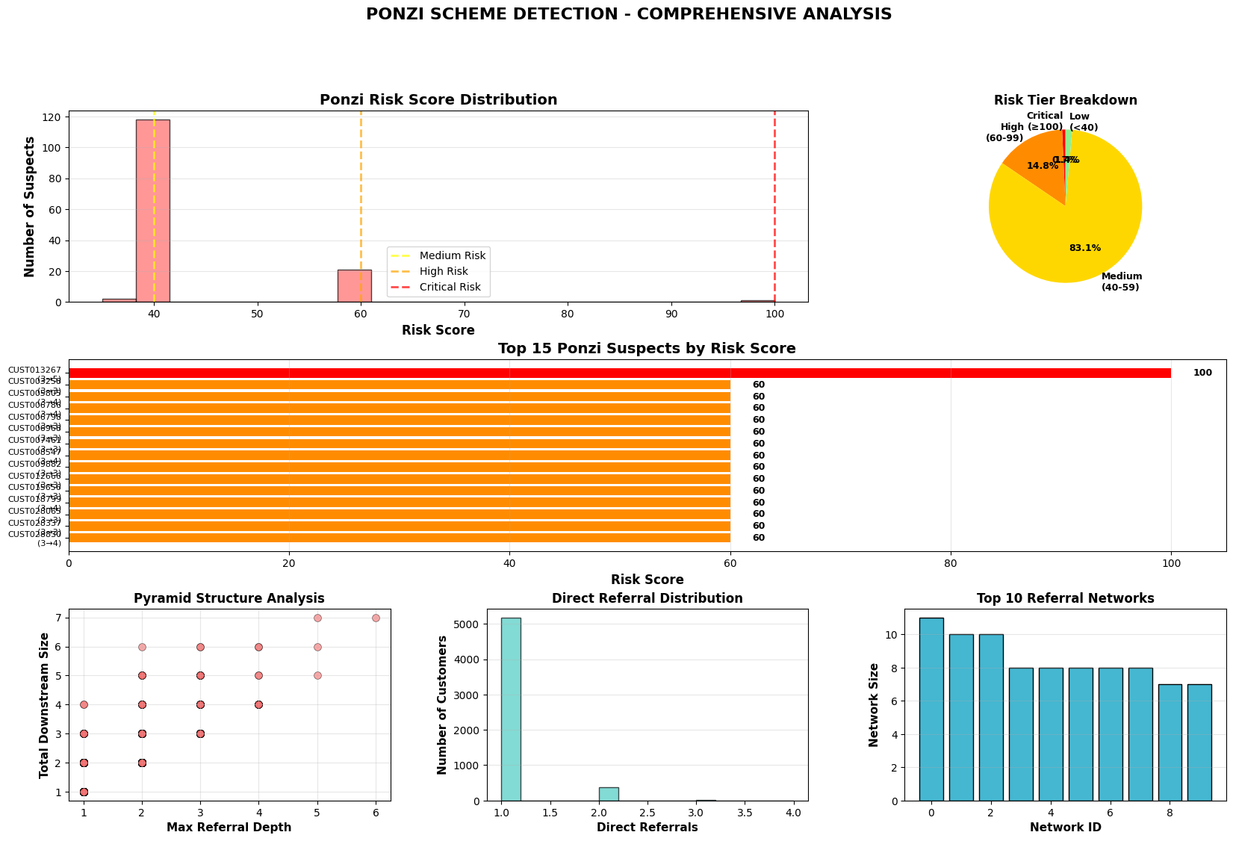
Visualizations generated!

====================================================================================================
✅ PONZI SCHEME DETECTION ANALYSIS COMPLETE
====================================================================================================

⚠️ RECOMMENDATION:
Customers marked as CRITICAL or HIGH RISK should be:
• Immediately flagged for investigation
• Subject to enhanced due diligence
• Monitored for suspicious transaction patterns
• Reported to compliance and regulatory authorities if confirmed

